Session-9 Database
- Create a SQL script to insert a new order into an Orders table, then use COMMIT to save the transaction and verify that the new order persists after reconnecting to the database.
Ans. START TRANSACTION;

INSERT INTO Orders
VALUES
(101,'maitri','Laptop',65000);
COMMIT;
 |  |  |  | order_id | customer_name | product_name | amount
 | Edit | Copy | Delete | 101 | maitri | Laptop | 65000.00

- Simulate a Zomato-style food order process: insert two new items into an OrderItems table, then use ROLLBACK to undo the changes before committing. Check that no new items remain in the table after rollback.
Ans. CREATE TABLE OrderItems (
item_id INT PRIMARY KEY,
item_name VARCHAR(50),
price DECIMAL(10,2)
);
START TRANSACTION;

INSERT INTO OrderItems
VALUES
(1,'Pizza',300),
(2,'Burger',200);
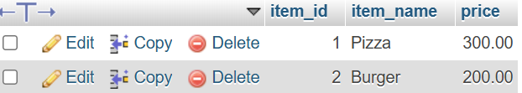

- In a Flipkart-like shopping cart scenario, use SAVEPOINT to mark a point after adding a product to the Cart table, add another product, then use ROLLBACK TO SAVEPOINT to undo only the last addition. Show the final contents of the Cart table.
Ans. CREATE TABLE Cart (
product_id INT PRIMARY KEY,
product_name VARCHAR(50),
price DECIMAL(10,2)
);
START TRANSACTION;

INSERT INTO Cart
VALUES
(1,'Mobile',25000);
INSERT INTO Cart
VALUES
(2,'Headphones',3000);
COMMIT;
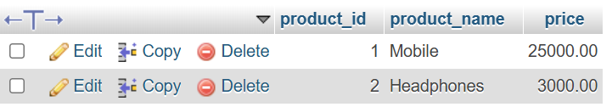

- Write a trigger on a Wallet table that automatically deducts the purchase amount from the user's balance whenever a new transaction is inserted, similar to how Paytm updates wallet balance after a payment
Ans. DELIMITER $$

CREATE TRIGGER wallet_trigger
AFTER INSERT ON Transactions
FOR EACH ROW
BEGIN

UPDATE Wallet
SET balance = balance - NEW.purchase_amount
WHERE user_id = NEW.user_id;

END $$

DELIMITER ;
INSERT INTO Transactions
VALUES
(101,1,1500);
SELECT * FROM Wallet;
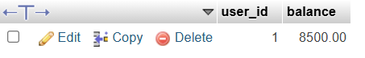
- Use ChatGPT to generate a SQL test scenario where a trigger incorrectly updates a user's balance after an expense entry. Paste the scenario and your corrected trigger code, explaining how you fixed the error.<br><br><em><strong>Hint:</strong> Ask ChatGPT for a buggy trigger example and a test case that exposes the bug.</em>
Ans. DELIMITER $$

CREATE TRIGGER correct_trigger
AFTER INSERT ON Transactions
FOR EACH ROW
BEGIN

UPDATE Wallet
SET balance = balance - NEW.purchase_amount
WHERE user_id = NEW.user_id;

END $$
DELIMITER ;


